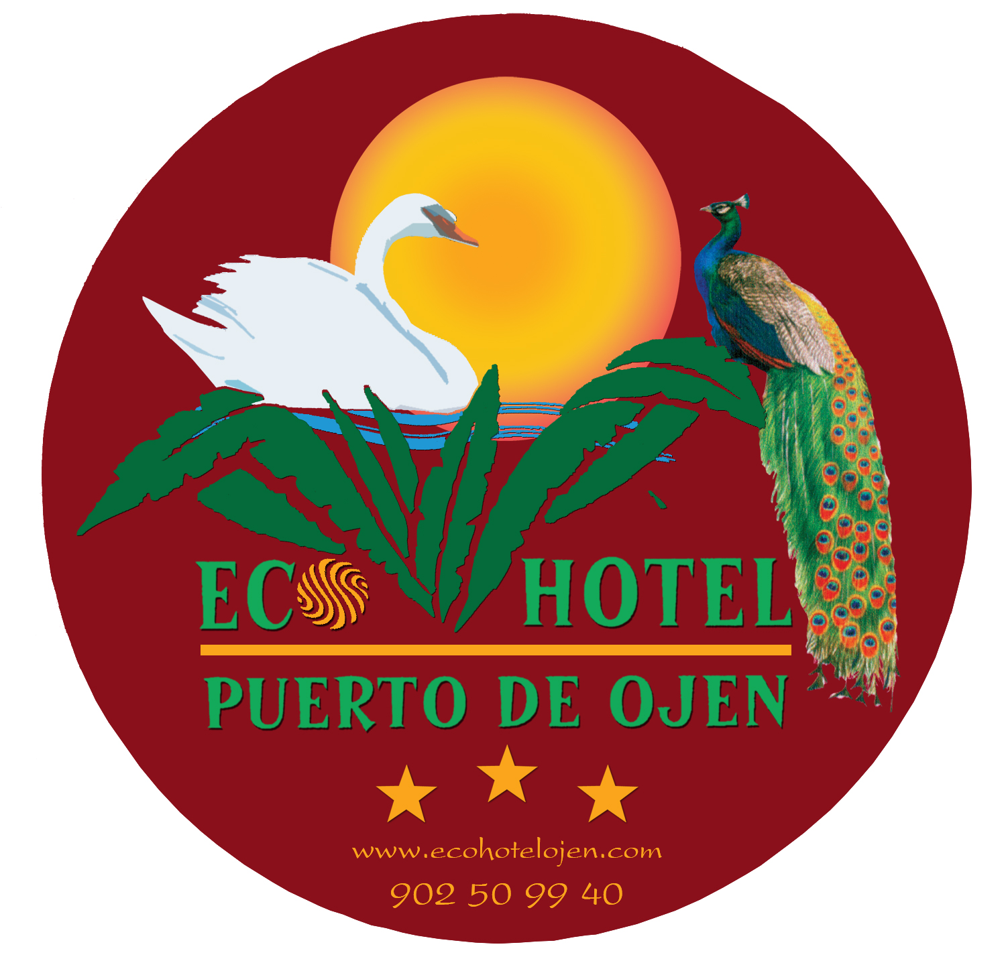

Dear guest,

The Ecohotel Puerto de Ojén management and staff would like to give you the most warm welcome and thank you for choosing our establishment for your next celebration.

Our facilities and qualified staff are at your disposal in order to make the event a complete success.

The guest´s full satisfaction is our philosophy and main purpose.

You can see that we offer a dish selection of different groups, so you can create the celebration menu as you like.

We do also are at your disposal, in case that, any non appearing option desired, could be satisfied, please do not hesitate to consult us.

We want to thank you again and we hope you to become a member in our huge list of satisfied clients.

The management

ECOHOTEL PUERTO DE OJÉN - BAR&REST. “MORAYMA” - CASA SPORT-CLUB ECOHOTEL

Puerto de Ojen s/n Telf. 902 50 99 40 – 951 05 09 50 Fax 951050959 29610 Ojén, Málaga, España (GPS- W 4º50’33’’-N 36º34’52’’)

www.ecohotelojen.com

Next we show you the different groups so you can create the menu as you like.

The prices are as follows:

- 2 dishes choice, no canapé selection from group 1 and 1 dish from group 2 or 3 plus dessert …………………40.00 €

- 2 dishes choice and canapé selection 1 from group 1 plus 1 dish from group 2 or 3 plus dessert ……………55.00 €

- 1 dish choice from every group …………………70.00 €

- Children´s menu ……………………………………18.00 €

Every menu has included the ornament and flowers on the tables plus foldout menu and welcome cocktail, where the following will be served:

Fine wine, white wine, red wine, beers, soft drinks and cava (Spanish sparkling wine), olives and crisps.

During the dinner the following will be served:

- White wine, “Crianza” (aged) Red Wine, Water, Coffee and Cava.

If you desire other wine of our cellar, please consult us without any obligation.

If you wish sherbets of our selection:

Lemon & vodka

Tangerine & Grand Marnier

Raspberry

Mango

Apple

Mint & rosemary

Price……………………………………………………………….3.00 €

Events menu 2009-2010

Cold Canapé selection Warm Canapé selection

Spanish Iberian ham Pork spicy sausage
Spanish cheese (Manchego) Spanish black pudding
Thick broth Salmon Battered squids
Anchovy & tomato toast Croquettes
Sea food puff pastry Cheese fritters
Roquefort cheese puff pastry
Spanish cold vegetable soup (Porra) tartlet

Group 1 Starters

-Cold asparagus with Spanish Iberian ham & dried fruits.

-3 Delights salad with Lettuce, marinated duck ham and goat cheese.

-Smoked salmon turban & king prawns with Mediterranean sauce (leek, onion and tomato vinaigrette).

-Pineapple quarter with strawberry & king prawns.

-Tropical fruits mousse with “San Lucar” king prawns, endives and blueberry sauce.

-Oporto flavoured melon cocktail with thinly sliced Spanish Iberian ham.

-Quince jelly “millefeuille” with goat cheese and apple.

-Foie toast with “Cumberland” sauce (Orange and redcurrant).

-Smoked salmon & traditional garnish.

-Marinated partridge salad with lettuce symphony & raspberry vinaigrette sauce.

-Smoked fish selection “millefeuille” & caviar vinaigrette.

-Avocado fan with king prawns & pink cocktail sauce.

-Carlos I (Cognac) flavoured Lobster “Bisque” (lobster cream).

-Pernod flavoured sea food & fish soup.

-Green asparagus soup & old cheese sticks.

Group 2 Fish

- Traditional style gilthead bream fillet.

-Bass fillet.

-Saffron flavoured salmon loin.

-Monkfish & vegetable sauce.

- “Vizcaína” style (red pepper sauce) cod fish.

-Grouper fillet with shrimp sauce.

-“Meunier” style (butter, lemon, parsley) sole fish fillet.

-Tuna loin with black olives vinaigrette.

-Halibut fillet with Carpediem wine.

-Hake “Suprêmes” battered with young eels.

-Sea bass crunchy fillet with mushrooms and thyme flavoured garlic.

-“Urta Roteña” (red banded seabream with garlic, onion, sherry wine, tomato) casserole.

- Saffron flavoured salmon fillet.

- Codfish “Au gratin” with plums.

- Grouper with “Palmitera” sauce (palm hearts, mushrooms, pine nuts).

Group 3 Meat

-Deer civet (casserole).

-Pork steak sirloin stuffed “Malaga” style (sweet wine).

-Marsala wine (Oporto) flavoured escalope.

-Medieval style roasted lamb shoulder.

-Green pepper steak sirloin medallion.

-Grilled Ox Tournedó (tenderloin centre) with “Perigord” sauce (meat juice, truffles, mushrooms, Oporto wine).

-Orange flavoured duck magret (breast).

-Stewed beef “Bonne femme” style (mushrooms, bacon, French onions, potato).

-Barbecued beef rump steak “Au jus” (in its juice)

-Herb flavoured marinated Iberian pork steak sirloin.

-“Maître Hotel “ (butter, lemon, Lea & Perrins sauce, parsley) fillet steak.

-Barbecued partridge “Toledana” style (Onion and bacon) casserole.

-Three peppers beef escalope.

-Rabbit with snails.

Group 4 Desserts

Wedding tart selection:

“Selva Negra”(3 chocolates)

Truffle

Wild berries

Strawberry & cream

EXTRAS

FREE BAR: 2 hours free bar 20€ per person, from the third hour on, a 5€ supplement per person will be charged, per bottle unit 60€ (refresh including).

Our selection: Cointreau, Bayleys, Tia Maria, Fruit liquors, Ron Bacardi, Cacique, Havana 3, Eristoff, Smirnoff, Ginebra Larios, Gordon`s, Beefeter, J.B., Ballantine`s, Cutty Sark, J.Walker.
Do not hesitate to ask us in case you want to change any drink.

- The waiters’ service is standard basis; if you wish to increase it, please consult us.
- The ornaments on the tables are standard type; if you desire anything special we will put you in contact with our provider.

We have at your disposal any entertainment that you wish.

SPECIAL CONDITIONS FOR WEDDINGS:

- 4 persons menu tasting, once the event has been contracted.

- Bed and Breakfast on the Nuptial suite the wedding night.

- 15 % discount for the party guests which decide to stay in the hotel.

CONDITIONS FOR THIS EVENT:

Booking deposit: 1.000 €, essential to make the booking effective.

50% additional on the menu tasting

Outstanding dues, to be paid at the end of the celebration.

VAT NOT included

